EXDON-18.10.2024
1. Find the incorrect subtypes in the illustration. Explain why you think the subtype is incorrect. Adjust the model to improve it.
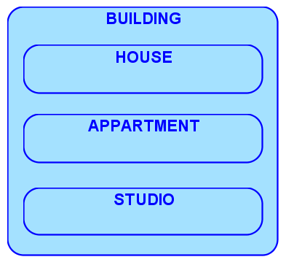
You can’t have only one suptype!
The Automobile has already multipel suptype of different car type.

2. Read the following scenario and construct an ERD that contains at least two subtypes of the entity PRODUCT. Show clearly which attributes belong to the entity supertype, and which belong to the subtypes. Identify a UID for the entity.
“Our shops sell several kinds of women’s clothing, including dresses, skirts and blouses. Of course each product has a name, a description, and a price. Oh, and sizes too: all products have a waist size. Dresses and skirts have a hem length but blouses don’t. Dresses and blouses have a chest size, but skirts don’t.”
